S.E.T.U Carlow

Robotic System Health Monitoring with Sensor Networks
A Dissertation Submitted to
Department of Engineering Technology,
In Candidacy for the Degree BEng (Hons) in Electronic Engineering,
By Patrick Duffy (C00281654)

Declaration

I understand that SETU Carlow and Wexford regards breaches of academic integrity and plagiarism as grave and serious.
I have read and understood the SETU Carlow and Wexford Plagiarism Policy. I accept the penalties that may be imposed should I engage in practice or practices that breach this policy.
I have identified and included the source of all facts, ideas, opinions, and viewpoints of others in the assignment references. Direct quotations from books, journal articles, internet sources, module text, or any other source whatsoever are acknowledged, and the sources cited are identified in the assignment references.
I declare that this material, which I now submit for assessment, is entirely my own work and has not been taken from the work of others save and to the extent that such work has been cited and acknowledged within the text of my work.
I have read and understood the SETU Carlow and Wexford library referencing guidelines (available at the TLC Student Hub on Blackboard) and/or recommended in the assignment guidelines and/or program documentation.
By signing this form or by submitting this material online I confirm that this assignment, or any part of it, has not been previously submitted by me or any other person for assessment on this or any other course of study.
By signing this form or by submitting material for assessment online I confirm that I have read and understood SETU Carlow and Wexford General Assessment Regulations, with a particular focus on Academic Integrity and Plagiarism Policy.

Signature: Patrick Duffy_______________________ Date: 24/4/2026

Table of Contents
Abstract 3
Introduction 3
Literature Review 4
IMU 4
Machine Learning 6
Convolutional Neural Networks 6
Recurrent Neural Networks 7
Machine Learning Choice 8
General Health Monitoring Methods 8
Design Implementation 9
Project Planning 9
IMU (Inertial Monitoring Unit) 10
CSV 11
Robot Movement Plan (RMP) 11
Collecting Data 12
Training the Model 13
Deploying the Model 16
Final Results 19
IMU Results 19
Training Results 20
Deployed Model 23
Conclusion 26
Works Cited 27
Appendix 27
IMU code 27
CSV code 29
Movement plan code 30
RNN training code 30
Deployed RNN code 39

Abstract
The reliability of a robotic system is vital in both industrial and consumer applications. Predictive maintenance offers a solution to minimise costly downtime by forecasting equipment failures in advance. This project will design and test a non-invasive health-monitoring system for robots using an Inertial Measurement Unit (IMU). The system aims to detect anomalies. The core of this work is the programming and training of a Neural Network, which can identify and distinguish between working motor and motor issues, with the goal of producing generalizable results that can be applied to a wide range of machinery.

Introduction
The focus of this project is to develop a system which can detect faults caused by motor issues in a robot. This can include a single issue or several, due to a variety of issues. To do this, an IMU will be used to read real-time acceleration data, and a Neural Network, which will take in the real-time acceleration data and use the trained weights of the Neural Network to determine if the robot is moving correctly or if there is a sign of a motor issue.
The results will then be used for generalised error detection, allowing the system to give the user a warning about the level of issue with the system, instead of a single working or not working statement.
This project will cover several sections, such as a literature review, in which it will look at different topics which are factors in this project. It will provide an overview of these factors and detailed descriptions of them. These factors include IMU, Machine learning, and other methods and projects related to robotic health monitoring systems.
It will then go over the design implementation of this project. This will cover the different sections needed to make this project and discuss how these sections were implemented, as well as the design choices made, from parameter selection to the methods used for testing the system.
The results gathered from testing and implementing the project will be discussed next, in which graphs and figures will be shown, and the results will be discussed to explain what they mean and how they show that the system is performing as expected or in a way that is beneficial to the project.
Finally, the conclusion includes a general discussion of the results, including talking about issues faced during the project and how they affected the project's development and results. It will also discuss potential implementations of the project in real-world systems, as well as future improvements or different lines of research that could be pursued with this project as a base.

Literature Review

IMU
Inertial Monitoring Units (IMU) are a group of sensors on one board. There are two main types. Two-sensor IMU and three-sensor IMU. A two-sensor IMU have an accelerometer and a gyroscope. The accelerometer measures acceleration values, and the gyroscope detects angular velocity. These have 6 degrees of freedom (DOF).
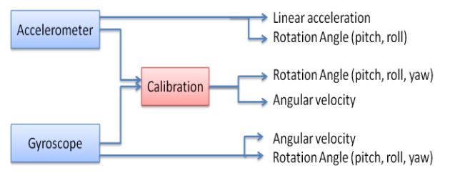
Figure 1: Two Sensor IMU (Ahmad, 2013)
The main issue with the two-sensor IMU is the gyroscope drift problem.
The other type of IMU is a three-sensor IMU. They have an accelerometer, a gyroscope and a magnetometer. These have 9 DOF, including a magnetometer. The accelerometer and gyroscope measure the same values, and the magnetometer measures the yaw angle rotation. This is then used to calibrate the gyroscope data, thereby improving the drift issue. This may improve the drift issue, but this type of sensor can't be used around ferromagnetic metal, as it will affect the magnetometer due to disturbances to the magnetic field.
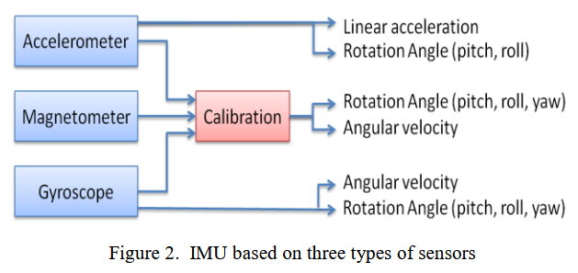
Figure 2: Three Sensor IMU (Ahmad, 2013)
While the main reasons to use a two-sensor IMU is it is cheaper both in cost and computational power, as there is no magnetometer being used to calibrate the gyroscope, the main reason for using the three sensors is due to the magnetometer which prevents the issue of gyroscope drift, there are also other considerations, such as Package Size, Data Accuracy, Response Rate, and Degree of Freedom. These different considerations will differ from application to application. Other considerations include the system for which the IMU is designed.
They have applications in many different sectors such as Manufacturing, Medical Rehabilitation, Robotics, Navigation Systems, Sports Training and Augmented Reality Systems
More specific applications include the accurate positioning of legged robots, allowing for uneven terrain (Mendes, 2003). Where IMUs are used in conjunction with forward kinematics, encoders, and an Extended Kalman Filter to estimate the robot's position without assuming a specific terrain. Similarly, it can be used in conjunction with a Kalman Filter to provide slip detection for skid-steered mobile robots (Bloesch, 2012). These two papers are both applicable to my project as one refers to use of IMUs with legged robots and the other is uses the IMUs for error detection (slip detection) which is the focus of my project although a different kind of error, This information in both these papers can be used in the project for example looking into using a Kalman Filter to help reduce noise and drift from the IMU.
While the Kalman Filter is used to help reduce drift, it is not the most effective way to reduce drift in a system utilising IMUs. Data fusion, combined with the Kalman filter, can be used to more effectively mitigate accumulated errors, which cause drift and increase the accuracy of the IMU (Zhao, 2012). This means using a reference sensor, such as an ultrasonic sensor, to help reduce the drift of the IMU. This is due to the digital compass (a Combination of the magnetometer and accelerometer) having a high sample rate but an issue of drift, while an ultrasonic sensor has a low sample rate but high accuracy. This is then used as a reference to get the position measurement, which is then fed into an Extended Kalman Filter (EKF), which produces accurate results specifically with the yaw, roll and pitch. While this project may not need to reduce accumulated errors as much, as it will only be using measurements collected under supervision and motion measurements of only a few moments at a time. Even with this, the methods presented in this paper can still be applied to the project to help reduce errors in my IMU, minimise the errors, and improve my measurements for the machine learning algorithm, which in turn will make my results more accurate, for example, instead of using a basic Kalman Filter, use an EKF.
IMU’s in recent years have become more popular in use in robotic systems particularly mobile robotic systems for localization of motion and navigation. Using acceleration, angular velocity and orientation. Some paper goes over the last five years of robotic systems and shows how IMU’s are being implanted more into robotic systems (Ayhan, 2006). While this isn’t directly related to my project it shows that in mobile robots IMU’s are common and my system could be then implemented into robotic systems without the need of adding a new IMU or re-engineering the system.

Machine Learning
From viewing other papers which use IMU’s for robotic health monitoring there are two types of Neural Networks that could be used, Convolutional Neural Networks (CNN) and Recurrent Neural Networks (RNN).

Convolutional Neural Networks
A Convolutional Neural Network (CNN) is a type of deep learning model primarily designed for processing structured grid data, such as images or time-series data. CNNs are a subset of feedforward neural networks, meaning data flows in one direction, from input to output, with no feedback loops. They are distinguished from standard neural networks by their use of convolutional layers, which apply learned filters to the input data to automatically extract relevant information (Jadeja, 2023).
A CNN is made up of three main layers, a convolutional layer which is the core of the network. It applies a filter, also referred to as a kernel, across the input data. As the filter moves across the input, it computes a dot product between the filter weights and the input values at each position, producing a feature map. This then identifies the local patterns such as edges, frequencies or repeated disorder within the data. Multiple filters can be applied simultaneously, with each of them learning to detect a different feature. A Rectified Linear Unit (ReLU) function is typically applied after each convolution.
The next main layer is the pooling layer, which is used to reduce the dimensionality of the feature maps. This is done by applying an aggregation function, such as taking the maximum pooling/value or the average pooling/value, across a small region of the feature map. This reduces the number of parameters in the model, lowering computational cost and helping to prevent overfitting.
The final layer is the fully connected layer, which takes the flattened output of the previous layers and performs classification or regression, connecting every node in the previous layer to every node in the output layer.
CNNs are used in a wide range of tasks, such as image classification and object detection. In the context of robotic health monitoring, CNNs can be applied directly to raw vibrational data, where a one-dimensional CNN can be trained to extract features along the time axis and classify different fault states (Alqatawneh, 2021).
While CNNs are powerful and well-suited for feature extraction from structured data, they do have some limitations, though. They require large amounts of labelled training data, can be computationally expensive to train and do not have the inherent ability to account for sequential data that relies on past outputs and inputs. It remains a challenge for CNNs to process time-series data effectively, as they are primarily designed to extract spatial features rather than capture relationships across time steps (Yang, 2019).

Recurrent Neural Networks
A Feedback Neural Network, also known as a Recurrent Neural Network (RNN), is the type of AI model to use for this project. RNNs work by taking the output or hidden state and feeding it back to the input of the next time step. 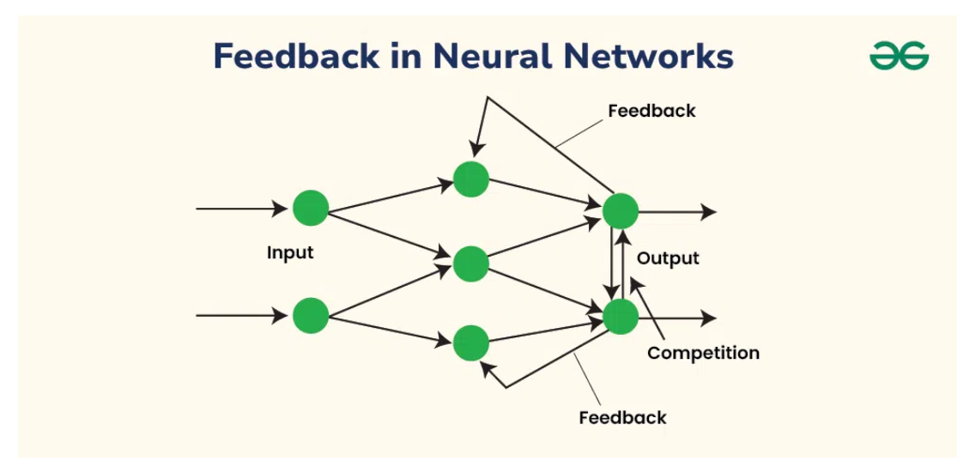
Figure 3: RNN diagram (GeeksforGeeks, 2024)
There are different types of RNN’s; these are one-to-one (Tx = Ty = 1, Tx being a single input and Ty is a single output). This is used in traditional neural network applications due to it having only a fixed size. This is the simplest type of RNN, which takes a single input (Tx) and produces a single output (Ty). One-to-many (Tx = 1, Ty > 1) is used in music generation or image captioning. It takes a single input and then outputs a sequence of data. Many-to-one (Tx > 1, Ty = 1) is used in sentiment classification. It takes many inputs but only has a single output. Many-to-many (Tx = Ty) is used in name entry recognition, there is also many-to-many (Tx ≠ Ty) which is used in machine translation (GeeksforGeeks, 2024). The difference between the two many-to-many is whether the input and output are the same length, and whether they are used in different applications. The first one has multiple inputs and outputs, but they are the same amount, while the second type of many-to-many has multiple inputs and outputs, but they are unequal. Advantages of RNNs in general are that the model size does not increase with input size, and weights are not shared across time. Some general disadvantages of RNN’s are that they are computationally complex. There are also issues with exploding gradients, which are due to the difficulty in capturing long-term dependencies because of gradients that can exponentially decrease or increase with the number of layers. This issue is resolved with the use of the Gated Recurrent Unit (GRU) and the Long Short-term Memory Unit (LSTM). LSTMs use memory cells that keep information over time. (GeeksforGeeks, 2025) It uses special gates to control the information. The input gate controls the new information to store, then a forget gate chooses the information that isn’t crucial to the RNN and removes it, and finally an output gate decides what information to pass on. This system allows it to remember information selectively, which makes it more effective at learning long-term dependencies. (GeeksforGeeks, 2025) While it reduces the exploding gradient problem, they also increase the computational complexity of the model when training, leading to more memory required and a longer time needed to train the model. GRUs are simpler versions of LSTMs; they combine the input and forget gates into just an update gate, reducing the number of parameters and computational complexity of the model. The update gate then decides how much of the information from the past outputs and inputs should be kept. The reset gate (Output gate) decides how much past information should be forgotten. This offers a balance between the model's performance and efficiency. While they are better than LSTM, they struggle with processing sequential data, meaning parallelisation is limited, and training is slowed with long sequences. While both LSTM and GRU have their limitations and disadvantages, they still reduce the problem of exploding gradients and are key to the implementation of an RNN.

Machine Learning Choice
Both CNNs and RNNs are viable options for this project, but an RNN is the better choice for a few reasons. Firstly, CNNs are good at identifying spatial patterns within structured data, such as images or fixed-length signal windows. While they can be used for time-series data, they do not naturally account for the past outputs or progression of the data. This is a serious limitation for this project, as the IMU data being collected is inherently sequential, meaning the relationship between one measurement and the next carries important diagnostic information.
An RNN, in contrast, is specifically designed to process sequential data by maintaining a hidden state that is passed forward through each time step, allowing the model to retain memory of previous inputs as it processes the current one. This makes it far better at capturing the patterns in IMU data, such as gradual changes in motion or the buildup of errors over time, which are the kind of signals this project aims to detect.
Due to these reasons, an RNN is more suitable for this project as it can handle past outputs and use them to help predict long-term issues, which is more suited for IMU data. It also requires less filtering than a CNN, which should make it simpler to implement and train.

General Health Monitoring Methods
There are different methods for monitoring the health of a robotic system. One of these methods is using IMU’s. Although there are also papers that refer to similar projects using different methods. In this implementation, they used several IMUs connected to a 3D printer and trained a machine learning model to process data from the IMUs and classify results based on different issues the 3D printer can encounter (Windau, 2018). The referenced project is similar to this one, but this project will primarily test with one IMU and then observe improvements in accuracy with multiple sensors. While this paper is not identical to this project, it will be used in the project at times for guidance, such as the Machine Learning model the project will use and the different ways of representing the results. Such as using a Feedback Neural Network.
While some methods use IMU, the focus of robotic health monitoring systems is the identification of issues. Feedback Neural Networks are shared for this, but the implementation will depend on the data. For example, vibrational data needs to be filtered before being used in the Neural Network (NN), such as putting it through a short-time Fourier transform (Su, 2007). Vibrational-based error detection requires this extra filtering to make sure the model uses motor vibration and not general vibration. Also, it converts the signal from the time domain to the frequency domain, providing more detail and making it easier to separate vibrations. While induction motor health monitoring is useful and practical. It is not without its issues.
Other methods of predictive health monitoring exist, such as using power efficiency to estimate robot health and detect faults (Yuan, 2011). This method is based on the idea that any mechanical or electrical issues that occur reduce the robot's power efficiency. This is logically sound, especially since they tested this method for both mechanical and electrical results and observed a decrease in efficiency from around 85% to 15%. Clearly indicating an issue with the motor. While this does indicate issues, the main issue is that on a system with multiple motors, the effectiveness of this method for specifying what is causing the issue needs to be tested and may not be as accurate for finding the specific issue.
Another approach to health monitoring in robotic systems focuses on fault detection within the power electronics stage, specifically voltage-source inverters supplying machines. They investigated several voltage-based techniques for detecting open-switch faults in inverter-fed motor drives. Their method compares measured voltages at different points in the drive system, such as inverter pole voltages, machine phase voltages, line voltages, and neutral voltages, with reference voltages generated by the PWM control signals. Any deviation between the measured and reference voltages indicates an error in the system and can be used to identify the specific faulty switch. One of the main advantages of this approach is its short detection time, with errors identified within a single cycle. However, the system requires additional voltage sensors and depends on accurate inverter modelling, which may increase system complexity and cost. While this method is effective for industrial motor drives, its applicability to distributed robotic systems is limited due to sensor and hardware constraints.

Design Implementation
This section will go through how this project was done, covering key parts. This included planning the implementation of the system. The code and implementation of the Inertial Monitoring Unit (IMU), the process for collecting data for the Recurrent Neural Network (RNN), training the RNN and the implementation of the RNN on the IMU. It will also discuss any issues faced or potential improvements that could be implemented into the project.

Project Planning
Starting project planning is important for staying on track and understanding the order in which different aspects of the project need to be completed. To do this, research on all components is needed. This includes researching the IMU and Robot hardware used, as well as the software needed for this project.
Next, a block diagram was made to act as a rough guide through the different steps needed in the project. While the block diagram will be rather linear, it is important because it prevents issues such as collecting data from the robot before the IMU is working correctly and having to move backwards in progress when a section is skipped. Having checks throughout the block diagram, such as whether the IMU data is stored, serves as a reminder to check the system and helps prevent issues from spreading further down the project, even though it can make the design process seem slower. The block diagram used for this project is shown below.
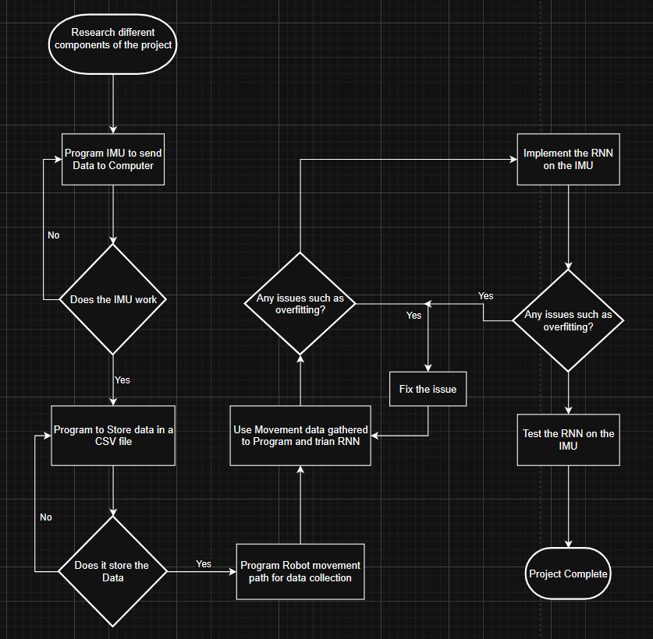
Figure 4: Project Block Diagram

IMU (Inertial Monitoring Unit)
The IMU used in this project was a Seeed Studio XIAO nRF52840. This is a 9-DOF IMU that contains an accelerometer, gyroscope, and magnetometer. It can use both Python and C using the Arduino compiler. For simplicity, C using the Arduino compiler can be used to visualize the real-time data without the need for additional code, and the Seeed Studio wiki has several guides on getting the IMU up and running in C, including sample code, which was used as it reduced the time needed to write the code significantly, as only small modifications were needed. Using the Seeed Studio wiki, the IMU’s library is needed for using the IMU and to use the example ‘HighLevelExample’ from the ‘Seeed Arduino LSM6DS3’ example set. This was then modified by shortening the example code, since only the acceleration data was used in the Machine Learning (ML) model; using the IMU's gyroscope and magnetometer would introduce delays to the system. The delay at the end of the code was also removed, since the accelerometer is configured at the start with several settings, such as frequency (set to 400Hz), so the delay is not needed; it would only stop the accelerometer from working at the correct frequency. Other settings that were set were bandwidth, which is 100, a range of ±4g, which means that the max and minimum values of the accelerometer are 4g and -4g and enable set to 1. Once this is finished, it needs to be tested. Initial testing was performed with the IMU on the table, connecting a Type-C cable between the IMU and the computer, and uploading the code from the Arduino IDE. Once run, you can select the serial plotter and move the IMU in linear directions to test the X, Y, and Z accelerations. This is not a perfect testing method, as there is no way to verify that the acceleration is accurate, but it will allow you to see how the acceleration changes to ensure it is working correctly. Do this several times at different speeds to see if it shows a difference in acceleration, not just that the IMU is accelerating. If the IMU shows a difference in acceleration between speeds, test going diagonally next, both at somewhat consistent speeds and at different speeds, to test how it handles multiple acceleration inputs.

CSV
A major part of this project relies on moving the acceleration data from the IMU to an Excel CSV file so that it can be used for training the Machine Learning model. A Python code is required to do this. It reads the data incoming from a specific port. In this case, it's COMM port 4, which is the USB port that the IMU was connected to. In the IMU code, Serial.print() was used when printing the acceleration data, as this sends the data to the connected COMM port so that other programs can read the data. You then need to write the Python code that first opens a CSV file. It then needs to connect to a COMM port as mentioned above. Once it is connected, you convert the data sent over the COMM port to a text format suited for Excel. This is then put through a while True: loop that doesn't end until it stops reading data from the COMM port. This is done in the IMU code with a for loop which loops 200,000 times.

Connect to COM4
While (i = 200,000 (Done in IMU)):
Read COM4
Convert data to text
Get the current time
Write data and time to CSV file
i =+
End while
Close COM4
Close CSV file
Pseudocode 1: CSV file writing

Robot Movement Plan (RMP)
Before the model can be trained, accelerometer data needs to be gathered from the robot. This data can come from a working robot or from an artificial issue given to the robot. As this project is using a Recurrent Neural Network (RNN), using only working robot movement data is good enough for it.
To start gathering data, you'll first have to download the software required for your robot. In this case, we are using the SIX – hexapod robot kit from EZ-Robot. For movement, this robot uses ARC as its main interface and connects to the laptop through Wi-Fi, which in turn has to be connected again in the software. Once it is connected, there are several ways to make the movement plan in the software.
These methods include RoboScratch, which is similar to Scratch but programming the robot; there is also Blockly, which is more advanced than RoboScratch, allowing for loops and other features rather than just simple movement blocks. For the movement plan in this project, JavaScript was used instead of the built-in tool, as when ARC closes, the scripts are not saved unless you have a subscription version of the software, so a JavaScript version allowed for the easiest method.
The movement plan was a simple loop of moving forward, then turning around 180 degrees, and finally moving in reverse. This is then repeated 100 times, although with a measurement speed of 4KHz, as mentioned in the IMU section, the robot was stopped before completing the for loop 100 times.
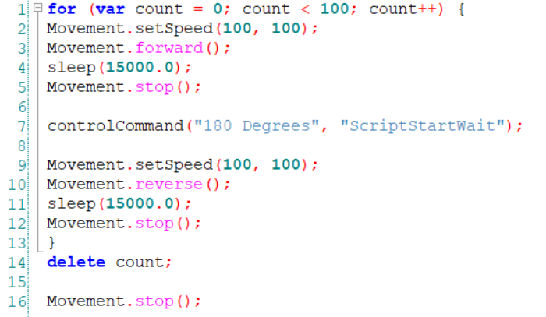
Figure 5: Movement Plan Code

Collecting Data
Once the IMU was working, the CSV logging code was logging correctly, and the robot was following the movement plan correctly without any issue, then you can start to collect the movement data. The IMU was fixed to the robot using blue tack. This method of fixation was chosen as it is easily reversible and adequately transfers the robot's motion. It was attached to the centre of the robot as shown below.
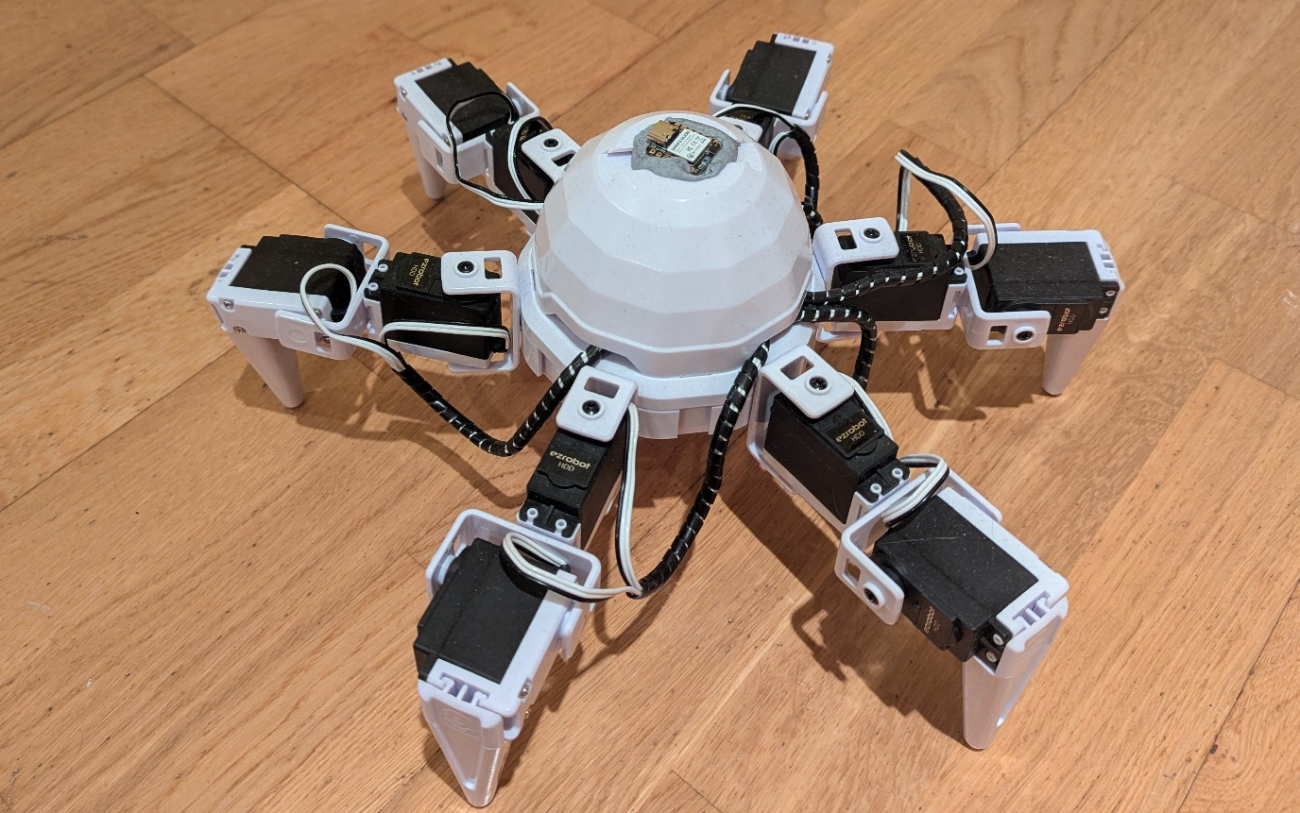
Figure 6: Robot with IMU attached
For this project, Blu-Tack was used to hold the IMU to the robot. This held the IMU stable relative to the robot and allowed any acceleration changes to be transferred from the robot to the IMU. It was chosen as time-wise, a custom holder would take too long, and Sellotape could potentially loosen, making it more difficult to gather movement acceleration data. Glue was also not a reasonable option, as the Robot was on loan from the college, and trying to remove the IMU from the Robot could possibly damage it.

Training the Model
Once the accelerometer data has been collected from the Robot and stored in a CSV file, the model can be built. First, before writing the model, there are two main options for programming it. You can program and run the model on hardware, which can be both intensive to the system and power-intensive, meaning in most cases this won't be feasible on your hardware, which can be both intensive to the system and power-intensive, due to a lack of hardware. Google Colab will be used then instead, as it runs independently on your system on better hardware.
As this is a Recurrent Neural Network (RNN) being programmed, Robot acceleration data is being processed without any issues. The aim is to train a model that can detect when the robot is working correctly. It does this by predicting the correct movement and then comparing it to the actual data. Depending on the deviation between the two, it can predict if there is an issue.
To do this, you first need to import the dataset into your program. For example, doing this in Collab, you need to mount your Google Drive, and then you can import it into the program from there. Once you have that done, you need to split the dataset into three parts: the training set, the test set and the validation set. In this project, the split was done with 60% of the dataset being used for training, while 20% was used for the training and validation set, respectively. A 60–20–20 ratio was chosen because the dataset had 200,000 data points. As seen below, the Excel file with accelerometer data goes to 453409, and with a space in between each read, that means there are 226705 data points in the set, 136023 data points in the training set and 45341 data points in the test and validation set, respectively. While you could have a separate validation set with such a large dataset, it is unnecessary to have a separate validation set.
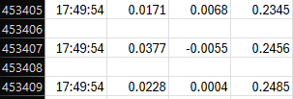
Figure 7: CSV Example
Once you have the dataset split up, you then need to configure the RNN with its input dimensions, hidden layer dimensions, number of layers and the dropout. Set the input dimensions to 3, since you have x, y, and z as inputs. The hidden dimension is the amount of memory stored in the system. In this project, the hidden dimension is set to 10, meaning 30 data points are saved for use within the system. 10 was chosen because, after testing different hidden layers, 20 was originally chosen as an arbitrary value, which was shown to cause overfitting due to complexity. As a result, 10 was tested, which prevented overfitting. This is due to 10 of X, Y and Z acceleration data being kept in the system. Increasing this can help improve the system, but also increases the computational complexity and the risk of exploding or imploding gradient. To prevent this, you can use Long Short-Term Memory (LSTM). This project uses LSTM because it helps reduce training time and prevents exploding and imploding gradients, which are common problems with LSTMs with large hidden layers or RNNs that have to detect small changes (GeeksforGeeks, 2025). In relation to this project, the small changes in acceleration. This is also affected by the number of layers. Having multiple layers has a few drawbacks, but a major benefit of having multiple layers is increased model capacity, which allows for better learning of subtle relationships, such as small changes in acceleration. In this project, there are 4 layers that enable the model to better predict relationships. Allowing the system to make better predictions. This does increase the computational expense and can lead to overfitting if you do not use dropout to reduce overfitting.
An important part of RNN is dropout. These drop (set to zero) random neurons during the training step. The amount depends on the percentage it is set to. The purpose of dropout is to prevent overfitting in the system. It does this by preventing the system from relying on any specific neuron order, thereby encouraging the model to learn more robust features. It also makes the model less sensitive to specific weights, helping the model to generalise better to new data. This project a dropout rate of 30% (0.3) is used as this is high enough to prevent any overfitting while not being so aggressive that it causes issues with training.
Batch size is a key part of any model. In a model, the dataset is divided into smaller subsets called batches, as feeding the entire dataset to the model at once can be computationally complex and, in most cases, especially with large datasets, impossible. In the model for each epoch, the training dataset is shuffled and then divided into batches of a specified size. In this project, the batch size is set to 32. This is a very common choice for batch size, as it provides a good balance between stable gradients and noise, helping generalisation. The model then processes one batch at a time, and it makes predictions for all samples in the batch. This is then repeated for all batches until the entire training data set has been processed. This helps to increase computational efficiency. A batch size of 32 works as a useful in-between, as small batch sizes can introduce noise into the system, but it can potentially help the model to generalise better. While larger batch sizes provide a more accurate estimate of the gradient, leading to smoother training curves, they can also reduce the generalisation.
Epochs are one complete pass of the entire training dataset through the model. During a single epoch, several things happen. First, the input data from a batch passes through the model, and then the model generates predictions. Then the model’s predictions and the actual target values are used to calculate the loss. The gradients of the losses with respect to the model’s weights are then calculated. Then the model adjusts the weights based on these gradients and the chosen optimiser, in the project's case, Adam is used to reduce the loss. This sequence of steps happens for every batch within an epoch. Once all batches have been processed, one epoch is complete. This is then repeated for every epoch. For this project, an epoch of 100 is used, and as the model goes through each epoch, it should learn underlying patterns in the data and ideally refine its understanding, and the loss on the training data should decrease.
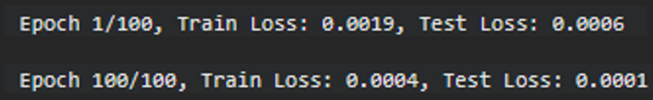
Figure 8 Model training epoch example
The more epochs you have, the longer the training time takes. For example, if 1 epoch takes 3 minutes and you have 10 epochs, it will take 30 minutes for the training to complete. This increases computational expense as well, but this is necessary as it helps reduce loss and improves the performance of the model.
Once the model is trained, there are several metrics that are calculated to show any issues within the model. Firstly, is the Mean Squared Error (MSE), which is the average of the squares of the error, where the error is the difference between the predicted values and the actual value. It is calculated by:
$$\frac{sum{\left(predicted-actual\right)}^{2}}{n}$$
Equation 1: Mean Squared Error
A lower MSE indicates a better fit of the model to the data. This leads it to be more sensitive to outliers. This is good as it can show if there are any major issues with your model's predictions, but can be thrown off with only a few outliers, even in larger sets.
Mean Absolute Error (MAE) is similar to MSE but is less sensitive to outliers as it takes the absolute difference instead of the squared difference. It gives a direct average of the magnitude of the errors in the same units as the target variable. For example, if it 10% off, it may show as 1000 or 0.1, depending on the units your model uses.
$$\frac{sum\left(\left|predicted-actual\right|\right)}{n}$$
Equation 2: Mean Absolute Error
The R-squared (Coefficient of Determination) is a statistical measure that represents the portion of the variance in the dependent variable (X, Y, and Z) that can be predicted from the independent variables (input sequence). It ranges from 0 to 1. The closer to 1 the R-squared value is, the better it predicts the variability of the target variable. Though a R-squared value of 1 seems to be the best, this could also indicate that the model is overfitting.
$$R^{2}=1-\frac{SSRES}{SSTOT}$$
Equation 3: R-squared
The SSRES term is the sum of the squares of the distances between the actual point and the predicted point. The SSTOT term is the sum of the squares of the distances between the actual point and the mean of all the points.
Plotting the results of the trained model's predictions for the test and validation sets is another important aspect, as it allows for identifying any issues and getting a better understanding of the model itself.
The final step in building the model is to export its weights. This is done by converting the weights from their internal format into an external format. In this project, this was done by converting it into a C++ format so that the Arduino code could read the model's weights. You then save the converted data onto your computer in the file format that you need for this project, which is a .h file. There is a necessary step to deploy the model on the robot.

Deploying the Model
Deploying the Model can be done in several ways, such as running it off of a computer or, in the case of this project, running it on the IMU itself. Due to using the SEEED Studio XIAO nRF52840, it can run light models on the IMU itself.
To run the model on the IMU, a few libraries are needed for the model. Firstly, you will need to include the exported model. It will need to be a .h file so that the Arduino code can read it. You will also need the LSM6DS3 library as this is the library for the IMU, this is necessary for getting the acceleration data that will be used in the deployed model. The wire and math libraries are also needed for communication and general maths needed in the program.
There are also some parameters that need to be configured as part of deploying the model.
Parameters | Value
accelerationThreshold | 0.5
numSamples | 120
INPUT_SIZE | 3
OUTPUT_SIZE | 3
HIDDEN_STATE | 10
NUM_LAYERS | 4
SAMPLE_PERIOD | 2404
MAE_THRESHOLD | 0.1385
Table 1: Deployed Model Parameters
The accelerationThreshold and the numSamples are both important parameters. The acceleration threshold is the acceleration that needs to be exceeded to start registering motion. This is set to 0.5. The number of samples is the number of samples that are taken each time motion is captured. This is set to 120.
INPUT_SIZE is another key parameter. This is set to three, as you have X, Y and Z, as these are the three parameters going into the model. The parameter OUTPUT_SIZE is also set to 3 as it's trying to reconstruct the input values.
Other parameters that are important for the model are the HIDDEN_SIZE, which is the number of neurons in the model; this is set to 10 in this project. There is also NUM_LAYERS this sets the number of layers in the system. This is set to four, meaning there are 4 LSTM layers in the system.
Another important parameter is SAMPLE_PERIOD, which sets the sampling frequency for IMU data collection. In the project, this parameter is set to 2500, which equates to a sampling frequency of 400Hz.
Classification threshold is another parameter that must be set. This is the MAE_THRESHOLD. This checks to see if the MAE is above that threshold. If it is above, the system will print a verdict that an issue exists, which is how it indicates a motor issue on the robot. This is done using a Boolean that compares the threshold to the actual MAE. In the program, the threshold is set to 0.13358. This was decided from trial and error to be a suitable threshold between working robot movement and incorrect movement from the robot.
Next, you need to set up the long and short-term memory. They are identical, other than the name. Long-term is the cell state (c_state), while short-term memory is the hidden state (h_state). This will be used later and needs to be set before used.
The LSTM cell is a key part of deploying the model. It is what allows the model to understand motion over time instead of just individual sensor readings. It starts with setting up the variables needed for the function. W_ih is the weights for inputs, W_hh is the weights for the hidden states, and there are also b_ih and b_hh, which are the biases for the inputs and hidden states. There are also variables for the current input and the size of the input.
Next is the input contribution, which starts with the bias of the system, then adds the weighted input values to the bias. This then affects the gate. Then it moves to the hidden-state contribution, which works similarly to the input contribution but uses hidden-state values instead of input values. This prepares for the main LSTM loop.
The main LTSM loop iterates over each hidden unit K in the LTSM layer and updates both the cell state and hidden state based on the current input and previous internal states. For each hidden unit, four intermediate values are computed: the input gate, forget gate, candidate state and output gate. A sigmoid function is used to constrain values between 0 and 1, enabling the gates to act as regulators. The hyperbolic tangent function tanh bounds values between -1 and 1, allowing the candidate state to represent both positive and negative contributions.
Once this stage is completed, the cell state, which is long-term memory, is updated using the equation.
$$ck\left(t\right)​=fk​⋅ck^{\left(t-1\right)​}+ik​⋅gk$$
Equation 4: long-term memory
This equation contains two parts; the first part is retention of previous memory ($fk​⋅ck^{\left(t-1\right)​}$), the forget gate determines how much of the prior cell state is preserved. The second part is the incorporation of new information ($ik​⋅gk$), the input gate controls how much of the candidate information is added. These two parts allow the LSTM to selectively retain or discard information over time, which is critical for modelling the sequential data.
The hidden state h[k],j represents the output of the LSTM cell at the current timestep. This is calculated using the formula.
$$hk^{\left(t\right)​}=ok​⋅\tanh\left(ck^{\left(t\right)​}\right)$$
Equation 5: Hidden State Equation
Nonlinearity tanh is used to update the cell state and scaling result by the output gate. The output gate thus regulates how much of the internal memory is exposed to the next layer.
The LSTM loop is important as it applies a nonlinear transformation to the gate values, updates long-term memory using control vector retention and input and generates short-term outputs for downstream processing. This makes it particularly suitable for motion analysis, as it can interpret data using both current and historical (past outputs and inputs) values.
The program then needs to convert the LSTM output into 3 values. This is done with the fully connected Layer function. It is simply a for loop which adds together the bias with the hidden state and weights multiplication matrix. This is represented with a formula.
$$output=W*h+b$$
Equation 6: Output equation
Then the program reset the memory with a function for each new motion sequence. Motion analysis is the next step in this program. In this step, it first computes the total error by summing the absolute output (predicted) minus the absolute input (actual) and dividing by N, which gives you the MAE. Then you check the MAE against the MAE threshold. If it is less than the MAE threshold, then the motion is correct; else, the motion is strange.
IMU settings need to be set, this includes the sample rate, bandwidth and accelerometer range. Accelerometer range in this project is set to 4 which means it can measure ±4g. This means it can measure any readings within this range. Then, the calibration procedure needs to be performed. This is done by taking 100 samples at rest, then computing the offset and removing bias from readings. This is needed to prevent offsets from messing up the MAE and causing false readings.
On start-up the system is configured for the baud rate required for communication. There is also the setup of the IMU before a serial connection is made. Then it checks whether the IMU has started working and prints to the serial port to confirm or deny its operation. Then it runs the calibration for the IMU and the function which resets the LSTM memory. Once those have completed, it prints the architecture of the model, including the hidden states, inputs, and outputs, and lets the user know it is waiting for motion.
The main loop starts with a while loop that checks for motion and doesn’t continue until motion is detected. Once motion is detected, it reads the X, Y and Z acceleration and subtracts the offset. It then normalises each axis into a range of 0 to 1 based on the range. It then stores the normalised input into inputSequence. These normalised values are run through the LSTM and then the fully connected layer. The output is then sorted into an output sequence.
Once 120 samples are collected, it calls the analyseMotion() function, which computes the MAE and compares it to the MAE threshold. Then, when it does this five times, it then compares the amount of the correct and incorrect motions and uses that to see if there is a potential issue, a minor issue, a major issue or if it is working correctly. It does this by assigning a score of +1 to positive results and -1 to negative results. Then a switch statement sees what the score is and gives the results based on this score. This is needed as it helps to show if any continuous issues are occurring instead of intermittent issues or a transient fault.
If (sample done)
MAE < MAE threshold = result + 1
MAE > MAE threshold = result – 1
)
Case(result)
result = 5
print “Working Correctly”
result = 4 to 1
print “Potential Issue”
result = 0 to -4
print “Issue”
result = 5
print “Major Issue”
Pseudocode 2:Generalised Error

Final Results

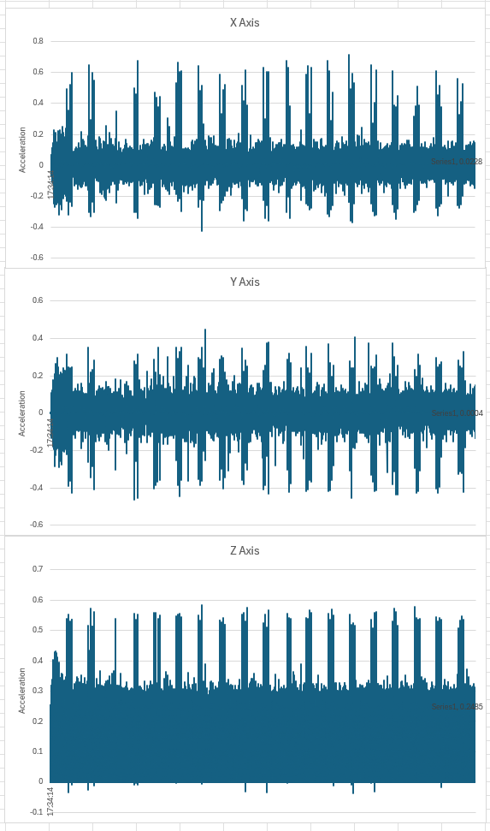
IMU Results

This shows the acceleration along the three axes (X, Y, and Z) during the collection of movement data. These graphs show the variation in data given from the movement plan and show that the collection program for the data is working correctly. Due to the frequency being 400Hz, this means the data has 400 data points per second, and as these data points span around ten minutes in total, the graph looks like a solid block around the zero axis when the robot wasn’t accelerating in that direction, or there was little acceleration in that direction. The Y axis is the smallest, as the robot didn’t move up or down except for when the motion required to move in a direction caused it to. While this may mean that the Y axis is not necessarily needed to get a model that can detect errors, it is still used as it is a datapoint which can still show errors, so it can be valuable to keep in the model.

Figure 9: IMU acceleration data

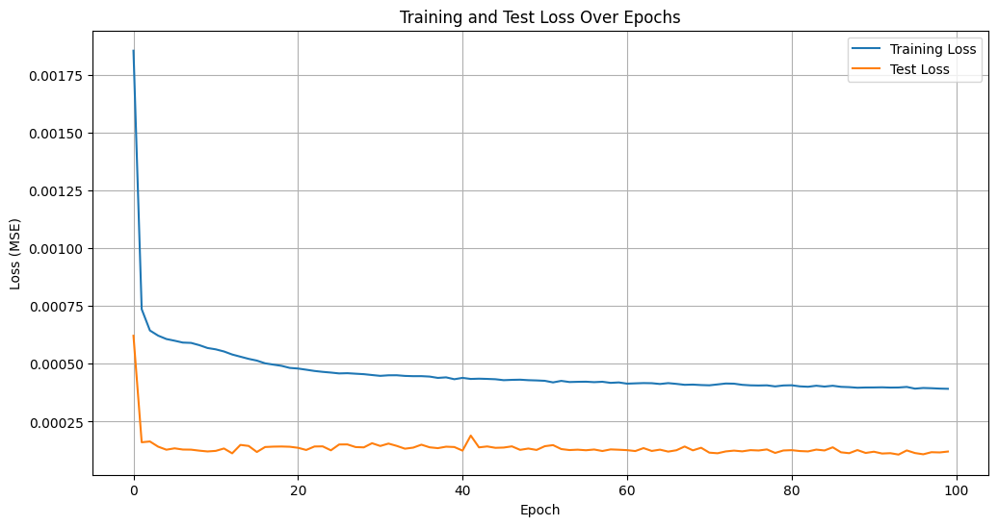
Figure 10: Epoch training and test loss graph
As shown in the graph above, as the epochs continue, there is an initial drop in training loss, and test loss decreases almost exponentially for the first few epochs. It then decreases at a slower rate until it reaches a plateau in training loss around 20 epochs. Test loss kept steady through the epochs after an initial decrease, with only slight changes through the multiple epochs. The total decrease in test loss was 16.6% rounded reduction in loss from the first epoch to the last, and there was a 21.1% rounded reduction in loss from the first to the second. The figures used to calculate the reduction in loss are shown in Figure 8 Model training epoch example. This shows that an epoch of around 50, or even 30, would be sufficient for training a model of this type.

Training Results
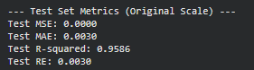
Figure 11: Test Metricsa
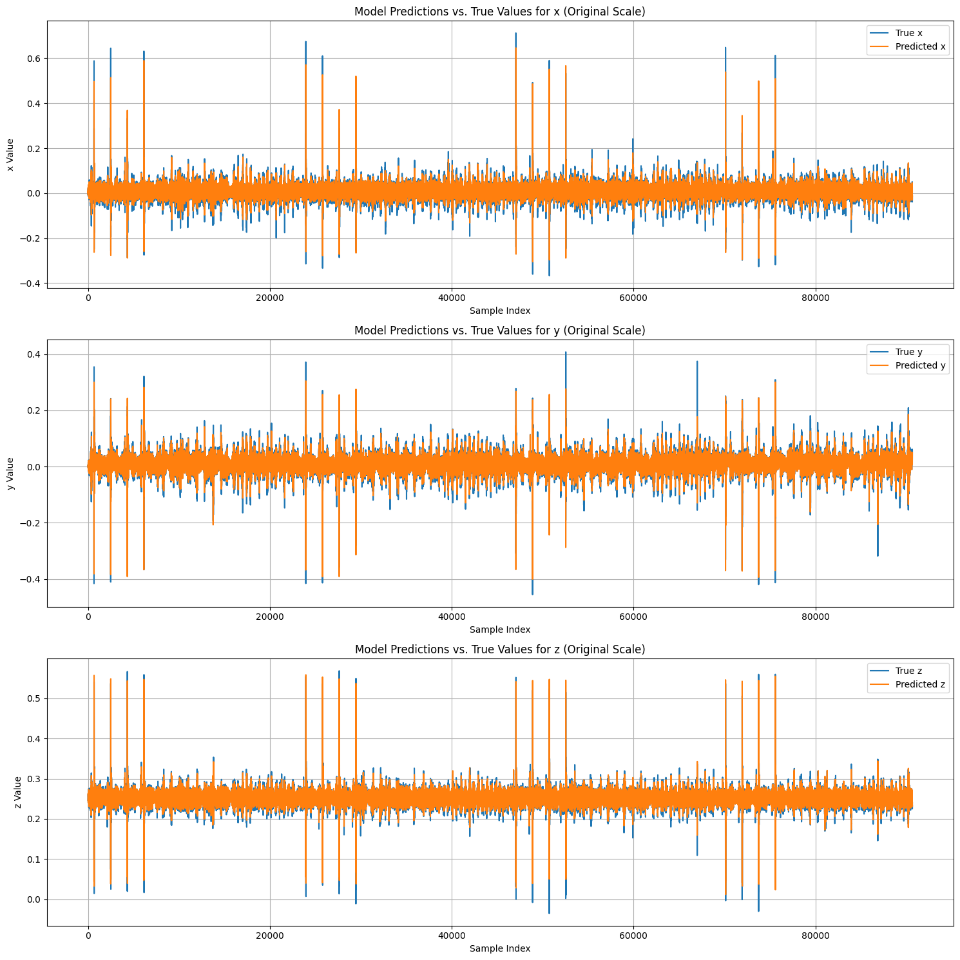
Figure 12: Test predictions vs actual value graphs

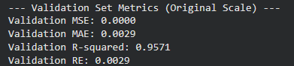
Figure 13: Validation Metrics
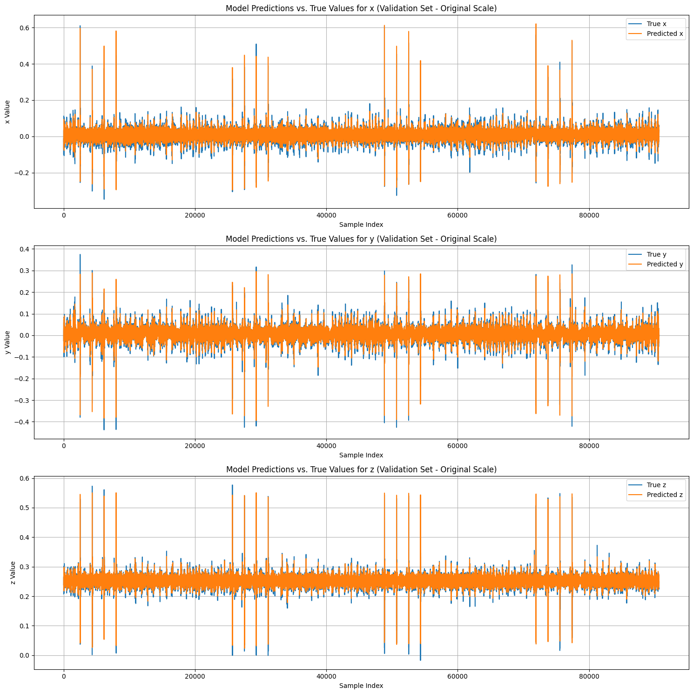
Figure 14: Validation predicted vs actual value graphs
As shown in the metrics and graphs for both the test and validation sets, this model is performing well in both prediction and calibration. This is seen through the MSE being zero; this is most likely due to the number being small enough that it is rounded to zero. This shows that both are being predicted very closely, indicating that the model is accurately predicting the values. This is also evident in the MAE, which measures the difference between the predicted and true values. For the test set, the MAE is 0.003; for the validation set, it is 0.0029. Just like the MSE, this shows a good predictive power and accuracy. The R-squared error indicates good generalisation, as it is 0.95 rather than 1, which would suggest the model is not overfitting. However, since two different sets verify the results, this indicates that the model is predicting accurately and generalising rather than overfitting to one dataset.
The graph also supports the conclusions from the metrics results, as from a visual inspection, you can see how the predicted result (orange) is similar to the true result (blue) without being identical to the true values. This is true for both the validation and test set, which also supports that there is no issue with overfitting in the model. These results verify that the model has good predictive power and accuracy, making it suited for deployment on the IMU. It should be able to predict values accurately and detect deviations from the predicted motion, allowing the system to accurately detect when an error is occurring.

Deployed Model
Three different results show different results from the IMU. The first one shows the robot working correctly, with no issues introduced. This gives us a result of “Working Correctly”. This is due to all five samples passing the MAE threshold, which in the code gives it a score of five. This score indicates that the robot motors are working as expected.
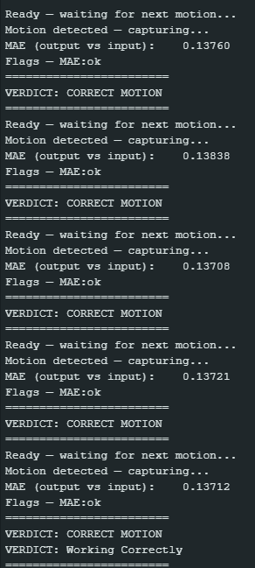
Figure 15: “Working Correctly” Generalised Verdict
The second result is from giving one servo more power than the others, demonstrating that it detects a motor issue. In this case motor is being supplied with a bit too much power. This gives us a “Potential Issue” result because the motor can still move, and some actions are mostly unaffected by this issue. It is also only a potential issue, as there could be other reasons, such as the robot being stuck on something or a similar issue.
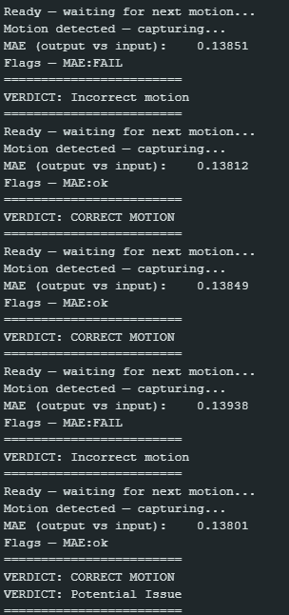
Figure 16: “Potential Issue” Generalised Verdict
Multiple motor issues are shown in the third result, which leads the system to respond with an “Issue” verdict. This can be caused by multiple smaller motor issues or by a single larger motor issue. During testing, more than one motor is undersupplied with power, leading to reduced performance. This causes multiple errors, triggering the system to show the result “Issue”, letting the user know that there is a serious issue with the motors.
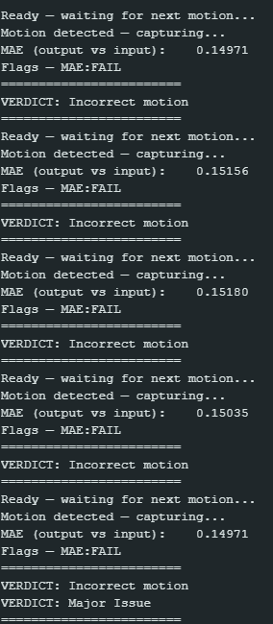
Figure 17: “Major Issue” Generalised Verdict
There is also “Major Issue” result. This occurs when you have issues with several motors at once. During experimentation, multiple motors were undersupplied with power, resulting in a serious issue. In my opinion, if this were deployed, this result should be connected to a power-off sequence to prevent any issues, especially if it were deployed in the manufacturing sector, where a major issue could cause risk to products or even cause harm to someone.
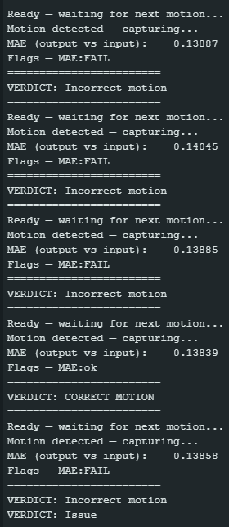
Figure 18: “Issue” Generalised Verdict
Through these results, we can see that the model is fully functional, showing results as it should and detecting issues with the motors. As the robot has six legs, this means that the results can vary depending on the motion it does, as it may not use a leg with a motor. To solve this issue, multiple parameters were used to show the level of the issue with the robot. This solved the problem with a potentially missed issue due to the leg with the motor that isn’t working correctly not being used in the action.

Conclusion
This project developed a system that uses a trained Recurrent Neural Network (RNN) to detect faults in a mobile robot, leveraging real-time IMU accelerometer data. There was a time constraint resulting from a change in advisor, as well as a change in the robot used. Instead of a Raspberry Pi micro-computer-controlled robot, a robot which uses priority software which limits the control and prevents the use of the robot as a central data and processing hub. The robot's ability to process data, which limited the processing power that could be used in this project to the IMU onboard processing power. Even with these issues, the system can give generalised results that, due to the training of the RNN only requiring working acceleration data instead of both working and error data, should be able to be implemented in a variety of machinery.
Even with it not being able to localise the motor issue, there are still applications for this system. These include manufacturing, where articulated arms are used, or in systems that use motors to move components. It could also be implemented in other mobile robots, such as a rover used for exploration, and the reduced complexity could reduce battery life, as you have only one IMU instead of an array of IMUs powered by the robot. It would also reduce the computational load on the mobile robot as the system can run the system on the IMU itself, while an array would need to be run on the robot, leading it to need to use more computational resources, which could be used for computer vision or object detection.
Future progress could be made by using an IMU array instead of a single IMU for error detection, enabling localised error detection. This would include procuring a robot that runs on an open-source processor such as a Raspberry Pi, allowing it to act as a hub for the system's processing. Another avenue for future progress could be to modify the system for other robotic systems, such as articulated arms or a conveyor system used in manufacturing.

Works Cited
Ahmad, N. R. G. R. K. N. K. V., 2013. Reviews on Various Inertial Measurement Unit (IMU) Sensor Applications. International Journal of Signal Processing Systems, December, Volume 1, p. 7.
Alqatawneh, I. a. D. R. a. R. K. a. C. Z. a. G. F. a. B. A. D., 2021. A Developed Convolutional Neural Network Architecture for Condition Monitoring}. 2021 26th International Conference on Automation and Computing (ICAC), pp. 1 - 6.
Amidi, A. a. A. S., 2019. CS 230 - Recurrent Neural Networks Cheatsheet. [Online]
Available at: https://stanford.edu/~shervine/teaching/cs-230/cheatsheet-recurrent-neural-networks
[Accessed 15 March 2026].
Ayhan, B. C. M.-Y. a. S. M.-H., 2006. IEEE Transactions on Industrial Electronics. [Online]
Available at: https://doi.org/10.1109/tie.2006.878301
[Accessed 2026 March 2026].
Bancroft, J. a. L. G., 2011. Data Fusion Algorithms for Multiple Inertial Measurement Units. Sensors, 29 June, 7(11), pp. 6771-6798.
Bloesch, M. H. M. H. M. L. S. G. C. D. C. a. S. R., 2012. State Estimation for Legged Robots - Consistent Fusion of Leg Kinematics and IMU. Robotics: Science and Systems VIII, July.p. 8.
GeeksforGeeks, 2024. Feedback Neural Networks: Structure, Training, and Applications. [Online]
Available at: https://www.geeksforgeeks.org/deep-learning/feedback-neural-networks-structure-training-and-applications/
[Accessed 4 January 2026].
GeeksforGeeks, 2025. RNN vs GRU vs Transformers. [Online]
Available at: https://www.geeksforgeeks.org/deep-learning/rnn-vs-lstm-vs-gru-vs-transformers/
[Accessed 15 March 2026].
Hackster.io, 2023. Capture data from Arduino to CSV using pySerial. [Online]
Available at: https://www.hackster.io/umpheki/capture-data-from-arduino-to-csv-using-pyserial-79fc88#code
[Accessed 2 January 2026].
Jadeja, V. a. R. A. L. N. a. S. A. a. S. S. a. C. P. a. B. G., 2023. Convolutional Neural Networks: A Comprehensive Review of Architectures and Application. 2023 6th International Conference on Contemporary Computing and Informatics (IC3I), Volume 6, pp. 460 - 467.
Jingang Yi, J. Z. D. S. a. S. J., 2007. IMU-based localization and slip estimation for skid-steered mobile robots. In: International Conference on Intelligent Robots and Systems. San Diego, CA, USA: IEEE/RSJ, pp. 2845-2850}.
Mendes, A. a. M. C. A., 2003. Fault detection of open-switch damage in voltage-fed PWM motor drive systems. IEEE Transactions on Power Electronics, October, 18(2), pp. 587 - 593.
Samatas, G. a. P. T., 2022. Inertial Measurement Units (IMUs) in Mobile Robots over the Last Five Years: A Review. Designs, 16 Febuary, 1(6), p. 17.
Studio, S., 2023. IMU Usage for XIAO nRF52840 Sense. [Online]
Available at: https://wiki.seeedstudio.com/XIAO-BLE-Sense-IMU-Usage/
[Accessed 2 January 2026].
Studio, S., n.d.. Getting Started with Seeed Studio XIAO nRF52840 (Sense). [Online]
Available at: https://wiki.seeedstudio.com/XIAO_BLE/
[Accessed 15 March 2026].
Su, H. a. C. K., 2007. Induction Machine Condition Monitoring Using Neural Network Modeling. IEEE Transactions on Industrial Electronics, Febuary, 54(1), pp. 241 - 249.
Windau, J. a. I. L., 2018. Inertial Machine Monitoring System for Automated Failure Detection. IEEE International Conference on Robotics and Automation , May.pp. 93 - 98.
Yang, C. a. J. W. a. G. Z., 2019. Time Series Data Classification Based on Dual Path CNN-RNN Cascade Network. IEEE Access, Volume 7, pp. 155304-155312.
Yuan, J. L. G. a. W. B., 2011. Power Efficiency Estimation-Based Health Monitoring and Fault Detection of Modular and Reconfigurable Robot. IEEE Transactions on Industrial Electronics, October, 58(10), pp. 4880-4887.
Zhao, H. a. W. Z., 2012. Motion Measurement Using Inertial Sensors, Ultrasonic Sensors, and Magnetometers With Extended Kalman Filter for Data Fusion. IEEE Sensors Journal, May, 12(5), pp. {943-953.

Appendix

IMU code
#include "LSM6DS3.h"
#include "Wire.h"

//Create a instance of class LSM6DS3
LSM6DS3 myIMU(I2C_MODE, 0x6A); //I2C device address 0x6A

const int ledPin = LED_BUILTIN; // pin to use for the LED
int incomingChar;

void config_PiCrawler_IMU() {

// ---- Accelerometer ----
myIMU.settings.accelEnabled = 1;
myIMU.settings.accelRange = 4; // ±4 g
myIMU.settings.accelSampleRate = 400; // Hz
myIMU.settings.accelBandWidth = 100; // LPF ~100 Hz

Serial.println("PiCrawler IMU configured for 400 Hz ±4 g / ±500 °/s with LPF ≈ 100 Hz");
}

void setup() {
Serial.begin(115200); //sets baud rate
while (!Serial);
pinMode(ledPin, OUTPUT);

if (myIMU.begin() != 0) { //Applies settings
Serial.println("Device error");
return;
}

Serial.println("Device OK!");
pinMode(ledPin, OUTPUT);
config_PiCrawler_IMU();
}

// Prints IMU data
void loop() {
for(int i = 0; i <= 200000; i++){
incomingChar = Serial.read();
Serial.print(myIMU.readFloatAccelX(), 4);
Serial.print(" , ");
Serial.print(myIMU.readFloatAccelY(), 4);
Serial.print(" , ");
Serial.print(myIMU.readFloatAccelZ(), 4);
Serial.print(" ,\n ");
}
}

CSV code
import serial
from datetime import datetime
import csv
i = 0
#Open a csv file and set it up to receive comma delimited input
logging = open('logging.csv',mode='a')
writer = csv.writer(logging, delimiter=",", escapechar=' ', quoting=csv.QUOTE_NONE)

#Open a serial port that is connected to an Arduino
ser = serial.Serial('COM4', baudrate=115200, timeout=1)
ser.flushInput()

while True:
#Read in data from Serial until \n n received
ser_bytes = ser.readline()
print(ser_bytes)

#Convert received bytes to text format
decoded_bytes = (ser_bytes[0:len(ser_bytes)-2].decode("utf-8"))
print(decoded_bytes)

#Retreive current time
c = datetime.now()
current_time = c.strftime('%H:%M:%S')
print(current_time)

#Write received data to CSV file
writer.writerow([current_time,decoded_bytes])

# Close port and CSV file to exit
ser.close()
logging.close()
print("logging finished")

Movement plan code
for (var count = 0; count <100; coutn++) {
Movement.setSpeed(100, 100);
Movement.forward();
sleep(15000.0);
Movement.stop();

controlCommand("180 Degrees", "ScriptStartwait");

Movement.setSpeed(100, 100);
Movement.reverse();
sleep(15000.0);
Movement.stop();
}
delete count;

Movement.stop();

RNN training code
import numpy as np
import torch
import torch.nn as nn
import pandas as pd
from google.colab import drive # importing your gdrive
drive.mount('/content/gdrive') # mounting your gdrive
import matplotlib.pyplot as plt
import torch.utils.data as data
from sklearn.metrics import r2_score, mean_absolute_error

column_names = ['timestamp', 'x', 'y', 'z']
dataset = pd.read_csv("/content/gdrive/MyDrive/logging.csv", header=None, names=column_names)
display(dataset.head())
features = dataset[['x', 'y', 'z']].values

class RegressionRNN(nn.Module):
def __init__(self, input_dim, hidden_dim, num_layers=1, dropout=0.0):
super().__init__()
self.rnn = nn.LSTM(
input_dim,
hidden_dim,
num_layers=num_layers,
dropout=dropout,
batch_first=True
)
self.fc = nn.Linear(hidden_dim, 3)

def forward(self, x):
_, (h_n, _) = self.rnn(x)
out = self.fc(h_n[-1])
return out

sequence_length = 100

X_sequences = []
y_targets = []

for i in range(len(features) - sequence_length + 1):
X_sequences.append(features[i : i + sequence_length])
y_targets.append(features[i + sequence_length - 1])

X = torch.tensor(np.array(X_sequences), dtype=torch.float32)
y = torch.tensor(np.array(y_targets), dtype=torch.float32)

train_size = int(0.6 * len(X))
test_size = int(0.2 * len(X))
valid_size = len(X) - train_size - test_size

X_train, y_train = X[:train_size], y[:train_size]
X_test, y_test = X[train_size : train_size + test_size], y[train_size : train_size + test_size]
X_valid, y_valid = X[train_size + test_size :], y[train_size + test_size :]

print(f"X_train shape: {X_train.shape}")
print(f"y_train shape: {y_train.shape}")
print(f"X_test shape: {X_test.shape}")
print(f"y_test shape: {y_test.shape}")
print(f"X_valid shape: {X_valid.shape}")
print(f"y_valid shape: {y_valid.shape}")

from sklearn.preprocessing import MinMaxScaler

scaler = MinMaxScaler(feature_range=(-1, 1))

features_df = pd.DataFrame(features)

outlier_threshold_x = 100.0
features_df.loc[features_df[0] > outlier_threshold_x, 0] = np.nan

features_cleaned = features_df.interpolate(method='linear', limit_direction='both')
features_cleaned = features_cleaned.fillna(method='bfill').fillna(method='ffill').values

features_scaled = scaler.fit_transform(features_cleaned)

X_sequences_scaled = []
y_targets_final = []

for i in range(len(features_scaled) - sequence_length + 1):
X_sequences_scaled.append(features_scaled[i : i + sequence_length])
y_targets_final.append(features_scaled[i + sequence_length - 1])

X = torch.tensor(np.array(X_sequences_scaled), dtype=torch.float32)
y = torch.tensor(np.array(y_targets_final), dtype=torch.float32)

train_size = int(0.6 * len(X))
test_size = int(0.2 * len(X))
valid_size = len(X) - train_size - test_size

X_train, y_train = X[:train_size], y[:train_size]
X_test, y_test = X[train_size : train_size + test_size], y[train_size : train_size + test_size]
X_valid, y_valid = X[train_size + test_size :], y[train_size + test_size :]

print(f"Scaled X_train shape: {X_train.shape}")
print(f"Scaled y_train shape: {y_train.shape}")
print(f"Scaled X_test shape: {X_test.shape}")
print(f"Scaled y_test shape: {y_test.shape}")
print(f"Scaled X_valid shape: {X_valid.shape}")
print(f"Scaled y_valid shape: {y_valid.shape}")

model = RegressionRNN(input_dim=3, hidden_dim=10, num_layers=4, dropout=0.3)

criterion = nn.MSELoss()
optimizer = torch.optim.Adam(model.parameters(), lr=0.001)

train_dataset = data.TensorDataset(X_train, y_train)
test_dataset = data.TensorDataset(X_test, y_test)
valid_dataset = data.TensorDataset(X_valid, y_valid)

batch_size = 32
train_loader = data.DataLoader(train_dataset, batch_size=batch_size, shuffle=True)
test_loader = data.DataLoader(test_dataset, batch_size=batch_size, shuffle=False)
valid_loader = data.DataLoader(valid_dataset, batch_size=batch_size, shuffle=False)

print(f"Number of training batches: {len(train_loader)}")
print(f"Number of testing batches: {len(test_loader)}")
print(f"Number of validation batches: {len(valid_loader)}")

num_epochs = 100

train_losses = []
test_losses = []

for epoch in range(num_epochs):
model.train()
total_train_loss = 0
for batch_X, batch_y in train_loader:
optimizer.zero_grad()
predictions = model(batch_X)
loss = criterion(predictions, batch_y)
loss.backward()
optimizer.step()
total_train_loss += loss.item()

model.eval()
with torch.no_grad():
total_test_loss = 0
for batch_X_test, batch_y_test in test_loader:
test_predictions = model(batch_X_test)
test_loss = criterion(test_predictions, batch_y_test)
total_test_loss += test_loss.item()

avg_train_loss = total_train_loss / len(train_loader)
avg_test_loss = total_test_loss / len(test_loader)
train_losses.append(avg_train_loss)
test_losses.append(avg_test_loss)
print(f"Epoch {epoch+1}/{num_epochs}, Train Loss: {avg_train_loss:.4f}, Test Loss: {avg_test_loss:.4f}")

model.eval()

with torch.no_grad():
scaled_test_predictions = model(X_test)

original_test_predictions = scaler.inverse_transform(scaled_test_predictions.cpu().numpy())
original_y_test = scaler.inverse_transform(y_test.cpu().numpy())

mse_original = nn.MSELoss()(torch.tensor(original_test_predictions), torch.tensor(original_y_test)).item()

r2_original = r2_score(original_y_test, original_test_predictions)

mae_original = mean_absolute_error(original_y_test, original_test_predictions)

residuals = original_y_test - original_test_predictions
avaerage_residuals = np.mean(np.abs(residuals))

print(f"\n--- Test Set Metrics (Original Scale) ---")
print(f"Test MSE: {mse_original:.8f}")
print(f"Test MAE: {mae_original:.4f}")
print(f"Test R-squared: {r2_original:.4f}")
print(f"Test RE: {avaerage_residuals:.4f}")

model.eval()

with torch.no_grad():
scaled_valid_predictions = model(X_valid)

original_valid_predictions = scaler.inverse_transform(scaled_valid_predictions.cpu().numpy())
original_y_valid = scaler.inverse_transform(y_valid.cpu().numpy())

mse_valid_original = nn.MSELoss()(torch.tensor(original_valid_predictions), torch.tensor(original_y_valid)).item()

r2_valid_original = r2_score(original_y_valid, original_valid_predictions)

mae_valid_original = mean_absolute_error(original_y_valid, original_valid_predictions)

residuals_valid = original_y_valid - original_valid_predictions
average_residuals_valid = np.mean(np.abs(residuals_valid))

print(f"\n--- Validation Set Metrics (Original Scale) ---")
print(f"Validation MSE: {mse_valid_original:.4f}")
print(f"Validation MAE: {mae_valid_original:.4f}")
print(f"Validation R-squared: {r2_valid_original:.4f}")
print(f"Validation RE: {average_residuals_valid:.4f}")

num_dimensions = original_y_valid.shape[1]
dimension_labels = ['x', 'y', 'z']

plt.figure(figsize=(15, 5 * num_dimensions))

for i in range(num_dimensions):
plt.subplot(num_dimensions, 1, i + 1)
plt.plot(original_y_valid[:, i], label=f'True {dimension_labels[i]}')
plt.plot(original_valid_predictions[:, i], label=f'Predicted {dimension_labels[i]}')
plt.title(f'Model Predictions vs. True Values for {dimension_labels[i]} (Validation Set - Original Scale)')
plt.xlabel('Sample Index')
plt.ylabel(f'{dimension_labels[i]} Value')
plt.legend()
plt.grid(True)

plt.tight_layout()
plt.show()

plt.figure(figsize=(12, 6))
plt.plot(train_losses, label='Training Loss')
plt.plot(test_losses, label='Test Loss')
plt.title('Training and Test Loss Over Epochs')
plt.xlabel('Epoch')
plt.ylabel('Loss (MSE)')
plt.legend()
plt.grid(True)
plt.show()

num_dimensions = original_y_test.shape[1]
dimension_labels = ['x', 'y', 'z']

plt.figure(figsize=(15, 5 * num_dimensions))

for i in range(num_dimensions):
plt.subplot(num_dimensions, 1, i + 1)
plt.plot(original_y_test[:, i], label=f'True {dimension_labels[i]}')
plt.plot(original_test_predictions[:, i], label=f'Predicted {dimension_labels[i]}')
plt.title(f'Model Predictions vs. True Values for {dimension_labels[i]} (Original Scale)')
plt.xlabel('Sample Index')
plt.ylabel(f'{dimension_labels[i]} Value')
plt.legend()
plt.grid(True)

plt.tight_layout()
plt.show()

def save_model_as_c_header(model, filename='regression_rnn_model.h'):
"""
Saves the PyTorch model's state dictionary parameters into a C++ header file.
Each parameter (weight/bias) is formatted as a `const float[]` array.
"""
state_dict = model.state_dict()
with open(filename, 'w') as f:
f.write("#ifndef REGRESSION_RNN_MODEL_H\n")
f.write("#define REGRESSION_RNN_MODEL_H\n\n")
f.write("#include <vector>\n\n")

for name, param in state_dict.items():
c_name = name.replace('.', '_').replace('-', '_')
param_flat = param.cpu().numpy().flatten()

formatted_values = [f"{val:.8f}f" for val in param_flat]
values_str = ""
for i in range(0, len(formatted_values), 10):
values_str += ", ".join(formatted_values[i:i+10])
if i + 10 < len(formatted_values):
values_str += ",\n "

f.write(f"const float {c_name}[] = {{\n {values_str}\n}};")

dim_values_str = ", ".join(map(str, param.shape))
f.write(f"\nconst int {c_name}_dims[] = {{{dim_values_str}}};")
f.write(f"\nconst int {c_name}_num_dims = {len(param.shape)};\n\n")

f.write("#endif // REGRESSION_RNN_MODEL_H\n")

print(f"Model parameters saved successfully to {filename}")

save_model_as_c_header(model, 'regression_rnn_model.h')

Deployed RNN code
#include <LSM6DS3.h>
#include <Wire.h>
#include <math.h>
#include "regression_rnn_model.h"

// CONFIGURATION
const float accelerationThreshold = 0.5;
const int numSamples = 120;
const int INPUT_SIZE = 3;
const int HIDDEN_SIZE = 10;
const int NUM_LAYERS = 4;
const int OUTPUT_SIZE = 3;
#define SAMPLE_PERIOD 2404

//CLASSIFICATION THRESHOLDS
const float MAE_THRESHOLD = 0.1385f;
const int LOCAL_WINDOW_SIZE = 10;
int Samplenum = 0;
int overallCorrect = 0;

// IMU
LSM6DS3 myIMU(I2C_MODE, 0x6A);
float offsetX = 0, offsetY = 0, offsetZ = 0;
int samplesRead = numSamples;

// LSTM STATE
float h_state[NUM_LAYERS][HIDDEN_SIZE];
float c_state[NUM_LAYERS][HIDDEN_SIZE];

// Buffers
float outputSequence[numSamples][OUTPUT_SIZE];
float inputSequence[numSamples][INPUT_SIZE];

inline float sigmoid(float x) {
return 1.0f / (1.0f + expf(-x));
}

// LSTM Cell
void lstm_cell(
const float* W_ih, const float* W_hh,
const float* b_ih, const float* b_hh,
const float* x_in, int input_sz,
float* h, float* c
) {
float gates[4 * HIDDEN_SIZE];

for (int i = 0; i < 4 * HIDDEN_SIZE; i++) {
gates[i] = b_ih[i];
for (int j = 0; j < input_sz; j++) {
gates[i] += W_ih[i * input_sz + j] * x_in[j];
}
}
for (int i = 0; i < 4 * HIDDEN_SIZE; i++) {
gates[i] += b_hh[i];
for (int j = 0; j < HIDDEN_SIZE; j++) {
gates[i] += W_hh[i * HIDDEN_SIZE + j] * h[j];
}
}

float* g_i = gates;
float* g_f = gates + HIDDEN_SIZE;
float* g_g = gates + 2 * HIDDEN_SIZE;
float* g_o = gates + 3 * HIDDEN_SIZE;

float new_h[HIDDEN_SIZE];
for (int k = 0; k < HIDDEN_SIZE; k++) {
float i_k = sigmoid(g_i[k]);
float f_k = sigmoid(g_f[k]);
float g_k = tanhf(g_g[k]);
float o_k = sigmoid(g_o[k]);
c[k] = f_k * c[k] + i_k * g_k;
new_h[k] = o_k * tanhf(c[k]);
}
memcpy(h, new_h, HIDDEN_SIZE * sizeof(float));
}

// Full 4-Layer LSTM Forward
void lstm_forward(const float* input, float* output) {
float layer_input[HIDDEN_SIZE];

lstm_cell(rnn_weight_ih_l0, rnn_weight_hh_l0,
rnn_bias_ih_l0, rnn_bias_hh_l0,
input, INPUT_SIZE, h_state[0], c_state[0]);
memcpy(layer_input, h_state[0], HIDDEN_SIZE * sizeof(float));

lstm_cell(rnn_weight_ih_l1, rnn_weight_hh_l1,
rnn_bias_ih_l1, rnn_bias_hh_l1,
layer_input, HIDDEN_SIZE, h_state[1], c_state[1]);
memcpy(layer_input, h_state[1], HIDDEN_SIZE * sizeof(float));

lstm_cell(rnn_weight_ih_l2, rnn_weight_hh_l2,
rnn_bias_ih_l2, rnn_bias_hh_l2,
layer_input, HIDDEN_SIZE, h_state[2], c_state[2]);
memcpy(layer_input, h_state[2], HIDDEN_SIZE * sizeof(float));

lstm_cell(rnn_weight_ih_l3, rnn_weight_hh_l3,
rnn_bias_ih_l3, rnn_bias_hh_l3,
layer_input, HIDDEN_SIZE, h_state[3], c_state[3]);

memcpy(output, h_state[3], HIDDEN_SIZE * sizeof(float));
}

// Fullt Connected Layer
void fc_forward(const float* input, float* output) {
for (int i = 0; i < OUTPUT_SIZE; i++) {
output[i] = fc_bias[i];
for (int j = 0; j < HIDDEN_SIZE; j++) {
output[i] += fc_weight[i * HIDDEN_SIZE + j] * input[j];
}
}
}

// Reset LSTM
void resetLSTMState() {
memset(h_state, 0, sizeof(h_state));
memset(c_state, 0, sizeof(c_state));
}

// Motion Analysis
bool analyseMotion() {

float totalError = 0.0f;
for (int t = 0; t < numSamples; t++) {
for (int j = 0; j < min(OUTPUT_SIZE, INPUT_SIZE); j++) {
totalError += fabs(outputSequence[t][j] - inputSequence[t][j]);
}
}
float mae = totalError / (numSamples * min(OUTPUT_SIZE, INPUT_SIZE));

// Printing Results
Serial.print("MAE (output vs input): "); Serial.println(mae, 5);

// Failed Result
bool failMAE = (mae > MAE_THRESHOLD);

Serial.print("Flags — MAE:"); Serial.println(failMAE ? "FAIL " : "ok ");

return !(failMAE);
}

// IMU Configuration
void config_PiCrawler_IMU() {
myIMU.settings.accelEnabled = 1;
myIMU.settings.accelRange = 4;
myIMU.settings.accelSampleRate = 400;
myIMU.settings.accelBandWidth = 200;
}

// IMU Calibration
void calibrateIMU(int samples = 100) {
float sumX = 0, sumY = 0, sumZ = 0;
Serial.println("Calibrating IMU — keep still...");
for (int i = 0; i < samples; i++) {
sumX += myIMU.readFloatAccelX();
sumY += myIMU.readFloatAccelY();
sumZ += myIMU.readFloatAccelZ();
delayMicroseconds(SAMPLE_PERIOD);
}
offsetX = sumX / samples;
offsetY = sumY / samples;
offsetZ = sumZ / samples;
Serial.println("Calibration complete.");
Serial.print("Offsets X/Y/Z: ");
Serial.print(offsetX, 4); Serial.print(", ");
Serial.print(offsetY, 4); Serial.print(", ");
Serial.println(offsetZ, 4);
}

void setup() {
Serial.begin(115200);
while (!Serial);

config_PiCrawler_IMU();

if (myIMU.begin() != 0) {
Serial.println("IMU error — halting.");
while (1);
}
Serial.println("IMU OK!");

calibrateIMU(100);
resetLSTMState();

Serial.println("Architecture: 4-layer LSTM | hidden=10 | input=3 | output=3");
Serial.println("Ready — waiting for motion...");

delay(500);
}

void loop() {
float aX, aY, aZ;

// Wait for significant motion
while (samplesRead == numSamples) {
aX = myIMU.readFloatAccelX() - offsetX;
aY = myIMU.readFloatAccelY() - offsetY;
aZ = myIMU.readFloatAccelZ() - offsetZ;

if ((fabs(aX) + fabs(aY) + fabs(aZ)) >= accelerationThreshold) {
samplesRead = 0;
resetLSTMState();
Serial.println("Motion detected — capturing...");
break;
}
}

// Feed timesteps one at a time
while (samplesRead < numSamples) {
unsigned long tStart = micros();

aX = myIMU.readFloatAccelX() - offsetX;
aY = myIMU.readFloatAccelY() - offsetY;
aZ = myIMU.readFloatAccelZ() - offsetZ;

float input[INPUT_SIZE];
input[0] = (aX + 4.0f) / 8.0f;
input[1] = (aY + 4.0f) / 8.0f;
input[2] = (aZ + 4.0f) / 8.0f;

for (int j = 0; j < INPUT_SIZE; j++) {
inputSequence[samplesRead][j] = input[j];
}

float lstm_out[HIDDEN_SIZE];
lstm_forward(input, lstm_out);

float fc_out[OUTPUT_SIZE];
fc_forward(lstm_out, fc_out);

for (int j = 0; j < OUTPUT_SIZE; j++) {
outputSequence[samplesRead][j] = fc_out[j];
}

samplesRead++;
// Get generalised error
if (samplesRead == numSamples) {
bool correct = analyseMotion();

Serial.println("========================");
if (correct) {
overallCorrect++;
Samplenum++;
Serial.println("VERDICT: CORRECT MOTION");
} else {
overallCorrect = overallCorrect -1;
Samplenum++;
Serial.println("VERDICT: Incorrect motion");
}

if(Samplenum == 5){
Serial.print("VERDICT: ");
switch (overallCorrect) {
case -1 ... 4:
Serial.println("Potential Issue");
overallCorrect = 0;
break;
case 5:
Serial.println("Working Correctly");
overallCorrect = 0;
break;
case -3 ... -2:
Serial.println("Issue");
overallCorrect = 0;
break;
case -6 ... -4:
Serial.println("Major Issue");
overallCorrect = 0;
break;
default:
overallCorrect = 0;
break;
}
Samplenum = 0;
}

Serial.println("========================");

delay(2.5);

Serial.println("Ready — waiting for next motion...");
}

while ((micros() - tStart) < SAMPLE_PERIOD);
}
}

